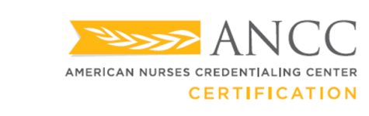

Success Pays®

Dear ,

Thank you for your interest in the Success Pays® program with American Nurses Credentialing Center (ANCC). Before applying for your certification, be sure you are ready to take the exam. Once you are ready to apply, follow the steps below.

**Application Steps:**

* [Create an ANCC account](https://ebiz.nursingworld.org/Login/Register?ReturnURL=https%3A%2F%2Fwww.nursingworld.org%2F) if you are not already an ANCC customer.
* Click on the appropriate [specialty certification](https://www.nursingworld.org/our-certifications/).
* After the page for your specialty has successfully loaded, click “Apply Online”.
* Select/Add Certification to cart.
* On the checkout page, enter your provided registration code in the “Enter Promotional Code” field.
* Click “Apply Promo” or the “tab” button to adjust the order total to $0.00.
* Click “Process My Order” toward the bottom left of the page as the final step of the certification registration process.

**Things to Remember After You Apply:**

* It will take 3-4 weeks to process an application, unless you go through the [Expedite Review Procedure](https://www.nursingworld.org/certification/certification-policies/expedited-review-procedure/), which will take only 5 business pays to process. There is a $200 for expediting an application.
* You will only have 90 days to schedule your exam once you receive your Eligibility to Test email from ANCC.
  + In the event that you are unable to test during the 90-day testing window, you may, **one time only**, request a new 90-day testing window. The exam reassignment fee is $100, which is the clinician’s responsibility and not part of the Success Pays program. This new testing window must begin less than 6 months from the last day of the initial testing window.
* Study Aids and CE can be found on each certification page.
* If you do not pass the exam the first time, you will be able to test again for free under the Success Pays program. You can only test **2** times per each certification.

Should you have any additional questions about the application process, please contact us at 1.800.284.2378 or via   
email at [certification@ana.org](mailto:certification@ana.org).

Sincerely,