Nurse Staffing Think Tank (NSTT)
Meeting Five (5) Minutes
Respectfully Submitted by Melissa Jones, PhD
March 8, 2022
Think Tank Members Present: Janet Ahlstrom, Carol Boston, Danielle Bowie, Natalia Cineas, Pam Cipriano, Amber Clayton, Vicki Good, Melinda Hancock, April Hansen, Helen Haskell, Peggy Lee, Ryan Miller, Sherry Perkins, Sarah Wells
Absent Think Tank Members: Vanessa Dawkins, Kiersten Henry, Rosanne Raso, David Tam
Facilitator: Regina Black Lennox
Nurse Staffing Core Team: Connie Barden, Katie Boston-Leary, Linda Cassidy, Wendy Cross, Sarah Delgado, Kendra McMillan
Nurse Staffing Core Team Absent: Cheryl Peterson
Nurse Staffing Partners attending: Robyn Begley, Patricia McGaffigan
Absent Nurse Staffing Partners: Todd Nelson
- Welcome – Katie Boston-Leary – The group is coming closer to a final deliverable. Thanks to the think tank participants for all they have contributed. We look forward to tonight’s work because it is a pivotal step toward creating something tangible.

- Affinity Exercise – Katie Boston-Leary
  - The affinity exercise was explained to the group (see Appendix for PowerPoint slides). The organization of the breakout rooms and the activity work were explained.
  - Group broke into five groups for a round-robin exercise to learn about and critique draft recommendations on the following five topics:
i. Healthy Work Environments
ii. innovative Care Delivery
iii. Work Scheduling Flexibility
iv. Total Compensation
v. Stress Injury Continuum

- Wrap-up
  - Return to main room – Each sub-group chose a representative to summarize their discussions for the entire group.
  - Two members have been working on a DEI component and will later share it with the group for feedback.
  - Due to time constraints, the “temperature check” was done via digital chat.
  - Next meeting overview — Moderator: At the next meeting we’ll be testing what’s been put together. It is very exciting to come to this bold and innovative document and will inform the future. Next meeting will be on March 22, 2022
IV. Adjournment - Meeting adjourned at 8:10 ET

Appendix - PowerPoint Slides for Affinity Exercise
Compiled and presented by Katie Boston-Leary

Slide 1
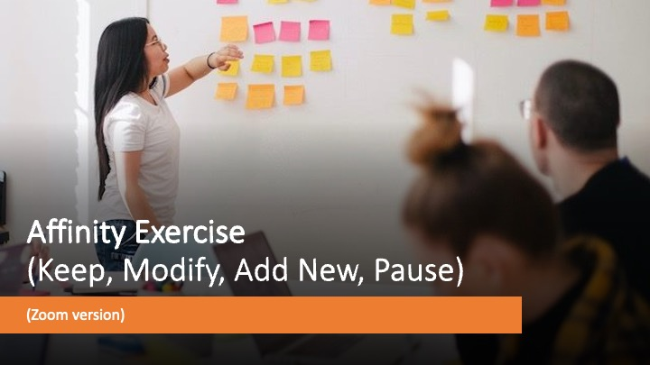

Slide 2
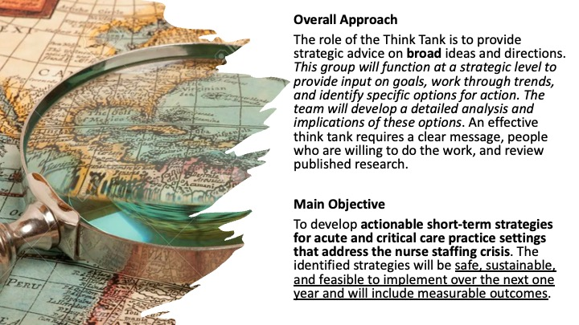

Slide 3

Slide 4
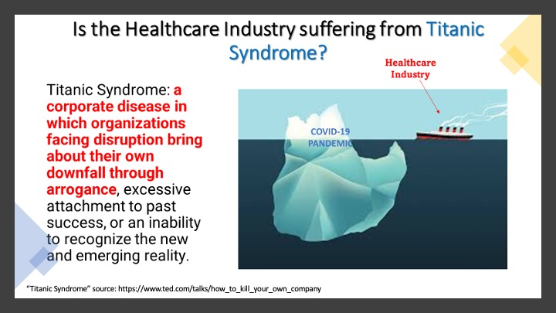

Slide 5
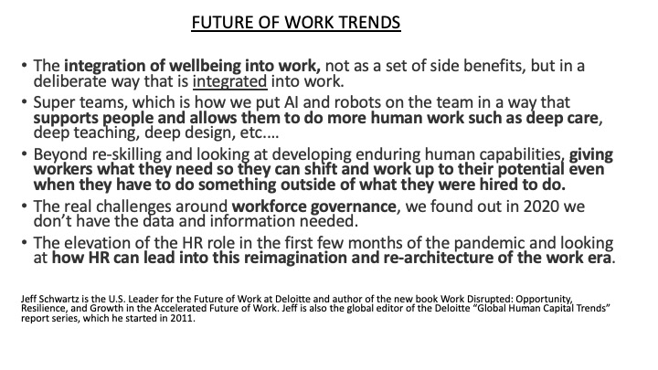
Slide 6

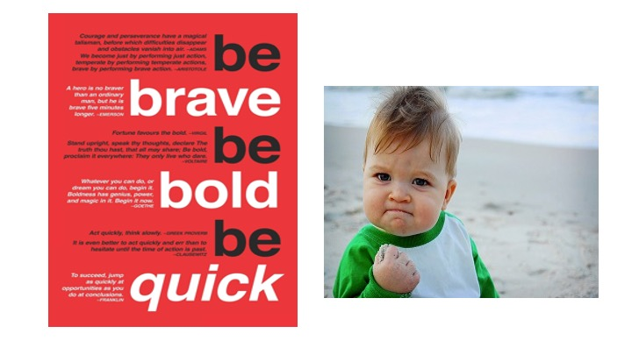

Slide 7

Slide 8
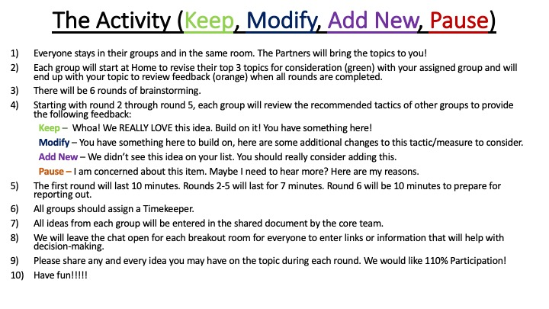

Slide 9
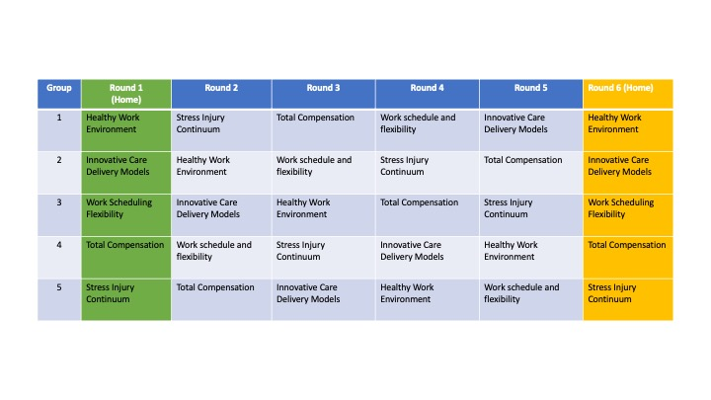
Slide 10
